

MyCalStateLA Quick Start Guide
Spring 2021, Version 1
Table of Contents
Accessing MyCalStateLA Portal 2
Signing into the Portal 2
Signing out of the Portal 3
Navigation 3
Quick Launch Applications 4
My Links 4
News 5
My Frequented Sites 5
Twitter 6

Accessing MyCalStateLA Portal

Signing into the Portal
When you visit the Portal you will be redirected to login to Office 365.

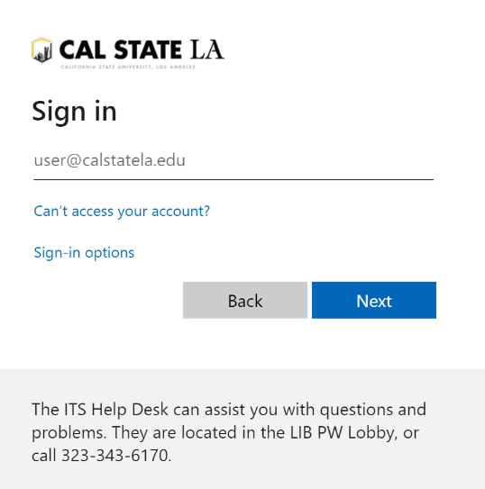
Figure 1 – Login Prompt

Enter your Cal State LA email address and click Next to enter your password.

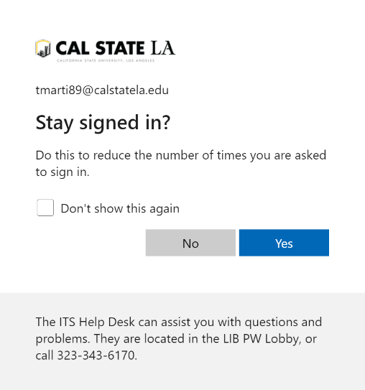
Figure 2 – Stay Signed In Prompt

After entering your password, you will be prompted to stay signed in. Only select “Yes” if you are the only user of the computer. If this is a public computer (such as in a lab), DO NOT select “Yes”.

Signing out of the Portal
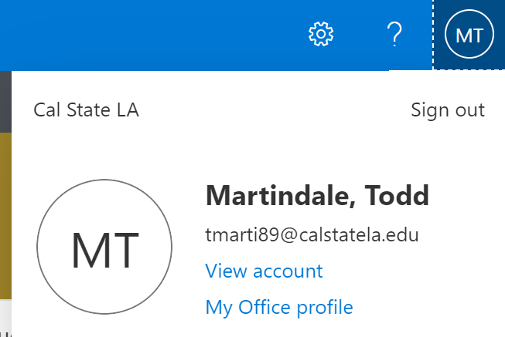
Click to sign out
Figure 3 – Profile Flyout Menu with Sign Out Option
To log out of your account, click on your profile in the top right of the browser window. Your profile may be represented as your initials, or your picture (if you have uploaded a profile picture). From the flyout menu, select “Sign out”.
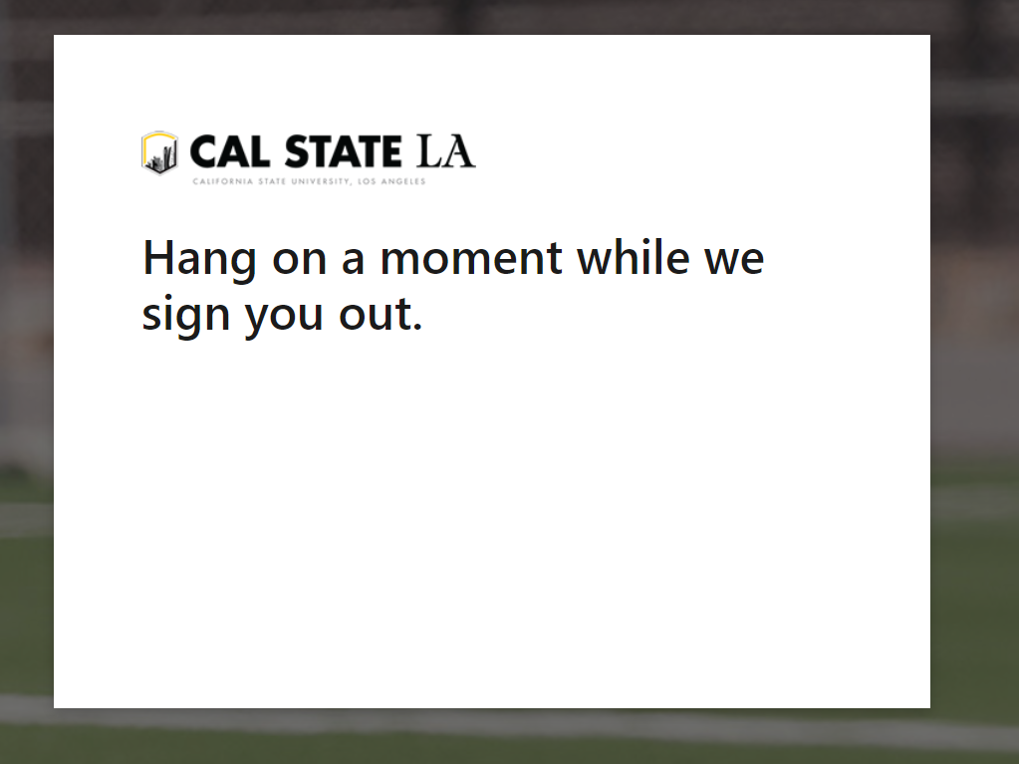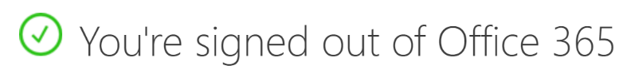
Figure 4 – Signing Out and Conformation Messages
You will first receive a message asking you to wait for the sign out to complete, and then a confirmation that sign out has completed. At this point, it is advised that you close the internet browser.

Navigation
Resources can be accessed via the navigation menu. Links may change over time for your target audience, such as student, faculty, etc.

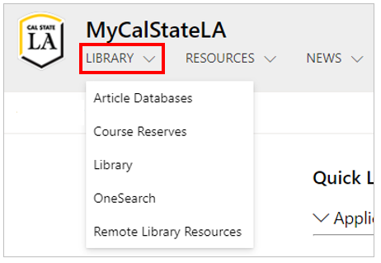
Figure 5 – Navigation Menu
Other sites within the portal can be accessed by clicking “Other Sites” in the hub menu:

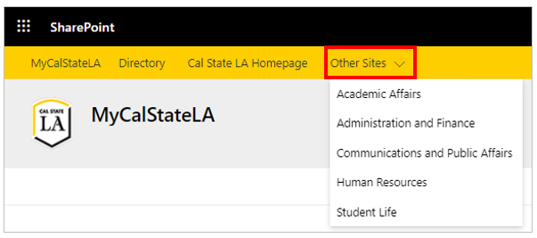
Figure 5 – Hub Menu

Quick Launch Applications
Quick Launch Applications are applications available to you. Applications are grouped by categories and can be marked as favorite for future quick access.
Clicking switch will toggle showing only your selected favorites.
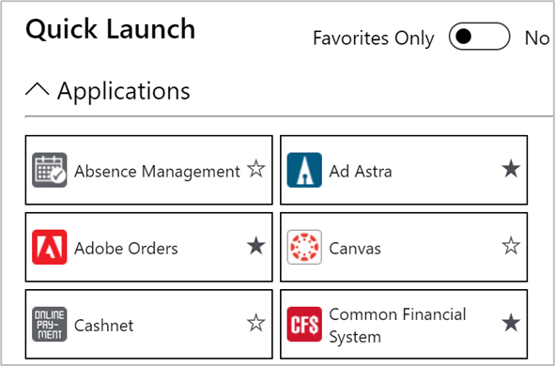

Clicking a star will toggle the application as a favorite.
Clicking on a button will open the application.
Caret will open or close category.
Figure 6 – Quick Launch Applications

My Links
My Links allow you to create links (bookmarks) that will be available to you when you login to MyCalStateLA.
Clicking the + button will open the Add New Link window.
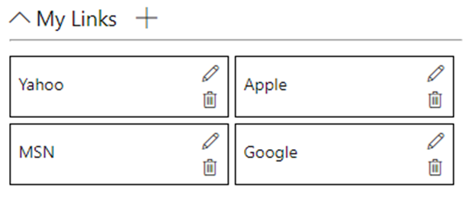

Buttons to edit (pencil) or delete (trash can) a link.

Clicking on a button will open the link.
Figure 7 – My Links

News
The news content section has news stories from various divisions.
Click to see all articles.
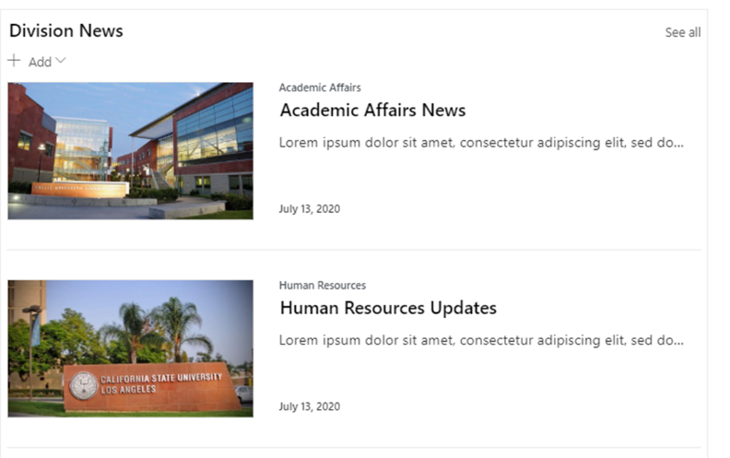

To view a featured news article, click on the article.

Figure 6 – News Stories

My Frequented Sites
This content section shows, and allows quick access to, the intranet sites you frequently access.

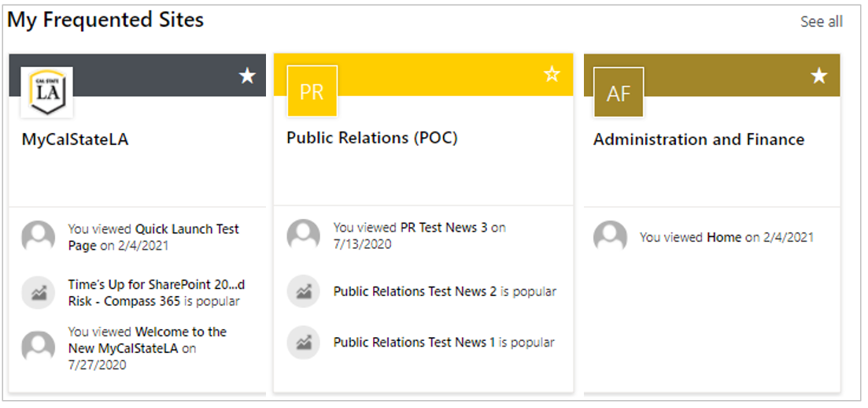
Figure 8 – Frequented Sites

Twitter
The Twitter feeds section shows tweets from Cal State LA Twitter accounts. Clicking on a tweet will take you directly to the tweet in Twitter.

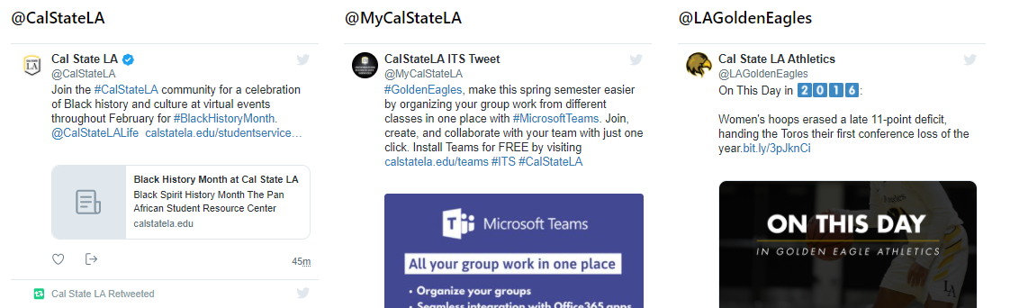
Figure 9 – News Stories

