 | HR 9.0 Release Notes  Maintenance Pack 15.00  Tools Platform 8.57.11

Release Date: | 03/19/21
Application Time: | 10 minutes
File Reference: | HR_90_HRMP1500_ Release_Notes_20210319

Table of Contents
Page
1.0 Definitions [Informational Only] 1
2.0 Prerequisites: [Campus Action Required] 1
2.1 Prerequisite List 1
3.0 Changes to Campus PeopleSoft Fileshare [Campus Action Required] 1
3.1 Copy the HR 9.0 Release Package for Maintenance Pack 15.00 1
3.2 Shut down Application Server and Process Scheduler 1
3.3 Run Repliweb to apply file share objects 2
4.0 Changes to the Application [ Informational Only ] 2
4.1 Summary of Release Changes 2
5.0 Importing the Maintenance Pack Project to Your Target Database 2
5.1 Clear Cache Files 2
5.2 Unzip the HR Maintenance Pack 15.00.zip file to C:\temp 2
5.3 Locate MP 15.00 Zip file 3
5.4 Set up HRMP 15.00 application via Change Assistant 3
5.5 HRMP15.00 Change Assistant Modification Steps – N/A 3
5.6 Apply HRMP 15.00 3
6.0 Manual Steps – Special Instructions 3
6.1 Clear app server cache and start process schedulers 3
6.2 Web Server Recycle PIA 3
7.0 Updating Security - [Campus Action Required] 4
7.1 Update Operator Security – N/A 4
7.2 Additional Security Updates – N/A 5
8.0 Audit Steps 5
8.1 Verify Database Stamp 5

Definitions [Informational Only]
Campus Action Required: Steps containing this label must be performed by the campus.

Prerequisites: [Campus Action Required]

Prerequisite List
- Oracle 12.1.0.2b
- All 9.2 Maintenance Packs Through HRMP 14.00

Changes to Campus PeopleSoft Fileshare [Campus Action Required]

Copy the HR 9.0 Release Package for Maintenance Pack 15.00
The Maintenance Pack Package consists of the following:
- Repliweb Job
- Project Library
 | IMPORTANT!!! Note for SA campuses: If you have a customized ECOUTMAP.sqc you must copy that into this new sa85513 fileshare and also attach your customized ECOUTMAP.sqc to your Help Desk Ticket when requesting the migration.
Repliweb Job
Your database/fileshare is located in the data center and you will have to install the fileshare via Repliweb. Instructions and training guides can be downloaded from the CMS Web Site at https://csyou.calstate.edu/Projects-Initiatives/CMS/TechSvcs/Pages/TSObjectMigration.aspx.
Project Library
The project library must be downloaded from the CMS Web Site at https://csyou.calstate.edu/Projects-Initiatives/CMS/CMSReleases/Pages/RelCMS.aspx. Locate the Project link, posted under this maintenance pack release. Follow the instructions contained within the package installation HRMP1500_20210319.zip file to install the new project. Any campus specific customized third party objects will need to be moved in to the target instance afterwards.

Shut down Application Server and Process Scheduler
EXAMPLE
- Run the ps_admin “stop_all” command.
  - sesudo ps_admin –d <dbname> -o stop_all

 | NOTE: The servers will be brought back up before starting the Manual Instructions in Section 7.1

Run Repliweb to apply file share objects
You will need to use Repliweb to apply the file share objects for HRMP15.00 which will be located under CMS_UPDATES_FIXES in Uniweb. Once the HRMP15.00 file share objects have been applied, you will need to use Repliweb to reapply any campus modified file share objects.
For detailed instructions on how to use RepliWeb, please refer to the RepliWeb User Guide located at https://csyou.calstate.edu/Projects-Initiatives/CMS/TechSvcs/Pages/TSObjectMigration.aspx.

Changes to the Application [ Informational Only ]

Summary of Release Changes
Please refer to the HR_90 Summary of Release Changes_HRMP1500_Tools85711_20210319.doc for detailed information regarding specific Help Desk Cases resolved in this maintenance pack.

Importing the Maintenance Pack Project to Your Target Database

Clear Cache Files
Clear the cache files on the local machine where the upgrade will be performed by deleting the contents of the C:\PS\Cache folder.

NOTE: No Oracle/PeopleSoft applications should be active while performing this step.

Unzip the HR Maintenance Pack 15.00.zip file to C:\temp

The following table illustrates the steps required to unzip the maintenance release package
Instructions | Illustration
- Unzip the HRMP 15.00 package to the C:\temp directory on your local drive.  - Select/Verify 'Extract' options. Settings should be:  - All files  - Use folder names | 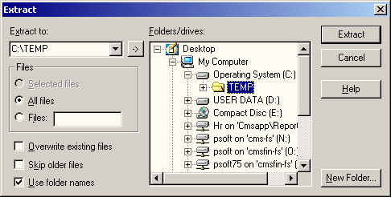

Locate MP 15.00 Zip file
The updBSL_UPG90_HRMP_15_00_CSU zip file for HRMP15.00 will be located in the HRMP_1500 folder. Please move this zip file to your Change Assistant Download directory
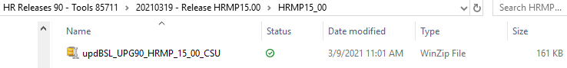

Set up HRMP 15.00 application via Change Assistant
Log on to Change Assistant as Administrator and perform any set up tasks for applying HRMP 15.00 to your Target Database.
NOTE: Please verify you are using an 8.57 version of Change Assistant when applying HRMP 15.00
NOTE: Any Warnings in the Check Compatibility setup step can be ignored.
CAMPUS NOTE: There is no project for HRMP 15.00. There is a ‘dummy project’ that is included in the zip file so the Change Package will load in Change Assistant.

HRMP15.00 Change Assistant Modification Steps – N/A

Apply HRMP 15.00
Start the Change Assistant process. Upon completion of the process, verify if any steps have warnings to review. Once any warnings have been marked complete and Change Assistant considers HRMP 15.00 completely applied, you can proceed with the HRMP15.00 application.

Manual Steps – Special Instructions

Clear app server cache and start process schedulers
Clear app server cache and restart app server and process schedulers using the ps_admin “clr_cache” command:
- Run the ps_admin “clr_cache” command.
  - sesudo ps_admin –d <dbname> -o clr_cache

- For complete instructions on how to use the ps_admin command, please refer to the CMS Oracle Enterprise Environment Administrators Guide, located at https://csyou.calstate.edu/Projects-Initiatives/CMS/TechSvcs/Pages/TSCampusLocEnvt.aspx.

Web Server Recycle PIA
The PIA recycle process entails, shutdown, cache purge, and then the startup of the PIA. Please follow these steps:
- Login to the campus web server (i.e. cxxdev100)
- Execute the “recycle_pia” command

sudo ps_admin -d <instance> -o recycle_pia

example: sudo ps_admin -d cbcmstst -o recycle_pia

Updating Security - [Campus Action Required]

Update Operator Security – N/A
NOTE: The PeopleSoft Security Administrator at your campus should perform the following steps.
The components listed below have changed as part of this upgrade package. Update operator security to access the following components as deemed appropriate by your campus.
# | MENU NAME | COMPONENT NAME

The following table illustrates how to update the operator security.
Instructions | Illustration
- Navigate to: Home > PeopleTools > Security > Permissions & Roles > Permission Lists  - Enter the name of the permission list that must be updated and click 'Search' to select the permission list.  Note: An example using the PPSUPER permission list is depicted. | 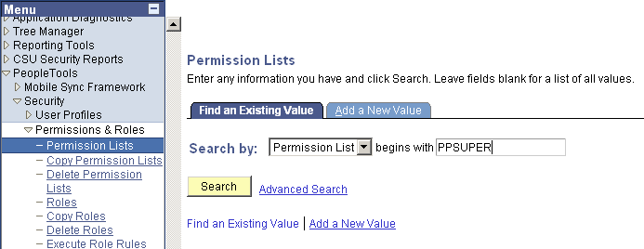
- The 'General' tab defaults.  - Select the 'Pages' tab to display the menus available for the permission list. | 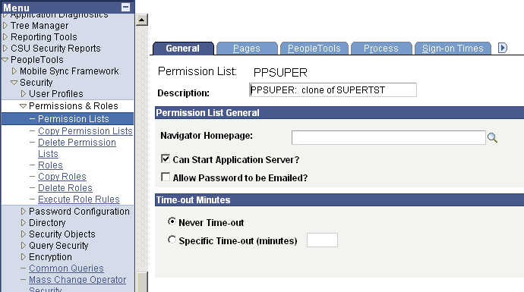
- Click 'Edit Components' for the required menu name.  - Note: A partial sample representation of the menus that may be displayed on the 'Pages' tab is depicted. | 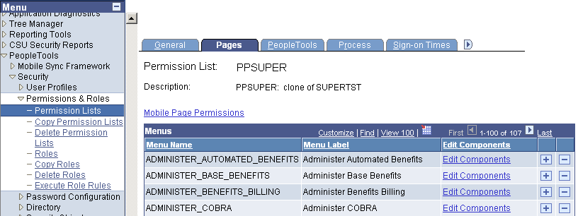
- Click 'Edit Pages' for the required component  - Provide access to new pages according to your campus security setup by clicking on the appropriate check boxes for the desired access. | 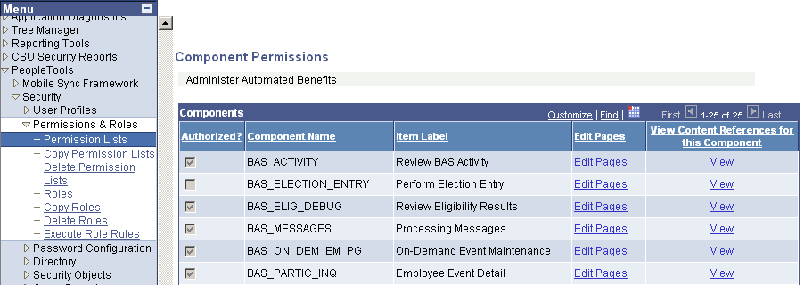

Additional Security Updates – N/A

Audit Steps

Verify Database Stamp
Verify the Stamp Database has been updated correctly:
Instructions | Illustration
- In the 'App Designer' menu select Tools > Upgrade > Stamp Database | 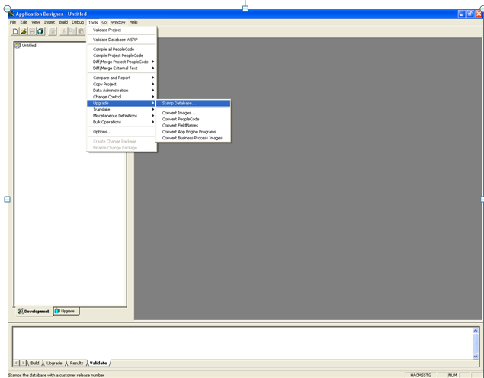
PeopleSoft Release  HRMS  - The Service Pack will be updated to 15  - The Customer Release will be updated to '000'  - Click 'Stamp' | 