WEBINAR PLANNING FORM

- First submit the webinar license request form.
Located on the ITS webpage: Webinar License Request Form
- After the Webinar License Request Form is approved log into MyCalStateLA portal.

- Go to the Zoom platform under SOFTWARE AND TOOLS.

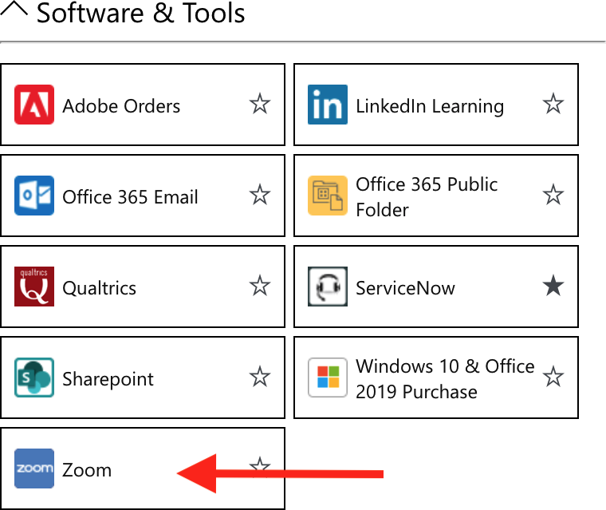

- Once it is approved it will show up in your Zoom account on the Left. This is where you can schedule the webinar.

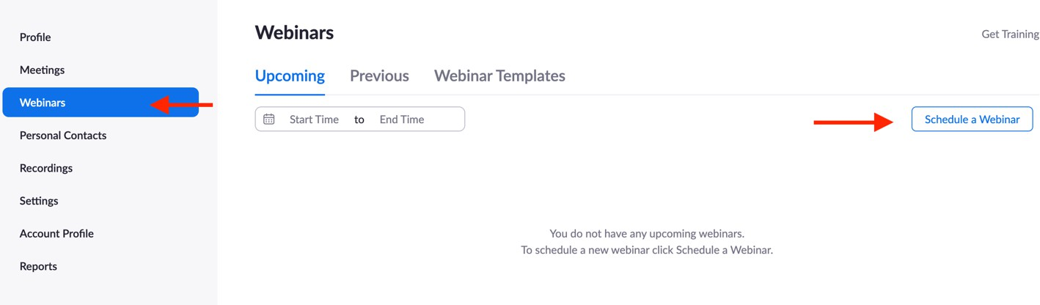

Additional Resources:

Watch tutorial on how to schedule webinar with registration.

Roles in a webinar

Spotlight feature

Submit Live Captions Request via the accessibility department:
SUBMIT LIVE CAPTION REQUEST

WEBINAR PLANNING FORM

Webinar Name: |  |  |  |  | Event Date:
Start Time: | End Time: | Tech Team Log in: | Panelist Log In: | Rehearsal Date: | Rehearsal Time:

*Tech Team: | Names: | Duties: *Roles in Webinar
HOST: |  | Start/Ends Webinar, ASSIGNS LIVE CAPTIONS, RECORDS.
Co-Host: |  | Screen Share – Beg/ending slides, Power Point, Video * etc.  *Will you be screening a video? Yes No
Co-Host: |  | Spotlights Guest (Need 3 participants with video ON and can be managed by host, or co-host)
Co-Host: |  | Manages audio - MUTE/UNMUTE when necessary
Co-Host: |  | Cues guest to TURN ON/OFF camera.
Co-Host: |  | Monitors the Q&A
Co-Host: |  | Other Duties
Co-Host: |  | Other Duties:

Guests Names: |  | Log in Time: | Sharing Materials:
Moderator
Panelist 1
Panelist 2
Panelist 3
Panelist 4
Panelist 5
Panelist 6
Panelist 7
Panelist 8
Panelist 9
Panelist 10
Panelist 11
Please fill out the Run of Show Sheet

Live Captions for Zoom Events

Machine Generated vs Live Captions:
The machine-generated captions are good for most situations, except:
- If the event is high-profile, we recommend using live captions.
- When someone who is Deaf or Hard-of-Hearing has requested captions, then we must use a live captionist. ( LIVE CAPTIONS REQUEST FORM) Submit 2-3 weeks before event.

Best Practices:
- Do not enable the Live transcription (machine-generated) if you will assign a live captionist.
- The following Live captioning accommodation request statement should be included in all your marketing materials prior to your event. Ex: flyers, webpages, registration pages etc.

“If you require Live captioning (closed captions) accommodation to attend this event, please contact 72 hours before the event start date.”

Assigning Captions:
The Live Captionist must be first added as a PANELIST, then the host assigns them to provide live captions for the event. Attendees choose whether to display captions or not. They must enable them.

Three Ways to Enable Captions:
- How to start manual closed captioning, or live captions in a meeting:
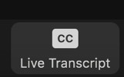
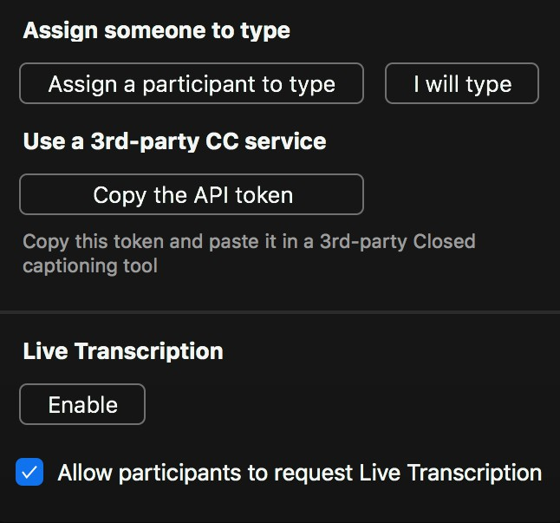
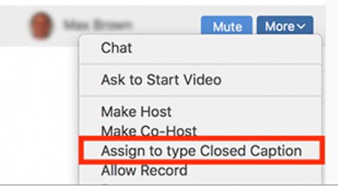
Live Captions: Hover over participants name and click more to assign them to type.
Manual: In Zoom click the closed captioning button then assign someone to type.

- When captionist use a third-party service to display the captions (ex: Streamtext) this will display captions on a separate window and serves as a workaround if you are having difficulties with the zoom captions. You must share the link provided by the Captionist with the attendees so that they can access the transcript. The StreamText generated captions can also display within Zoom if you use the API token. To use API token, Click on Copy API Token and share with Captionist.

- Live Transcription. This option is the Zoom generated captions.

