Encrypting files and folders

Password-protect using 7-Zip
- 7-Zip should be installed on all University-issued workstations. If the software is not on the workstation, please download the software at the following link by the appropriate operating system: https://www.7-zip.org/download.html
- Locate the file/folder of where the sensitive information is located.
Right-click on the located file/folder and there should be a 7-Zip selection. Hover over 7-Zip to open the following options:
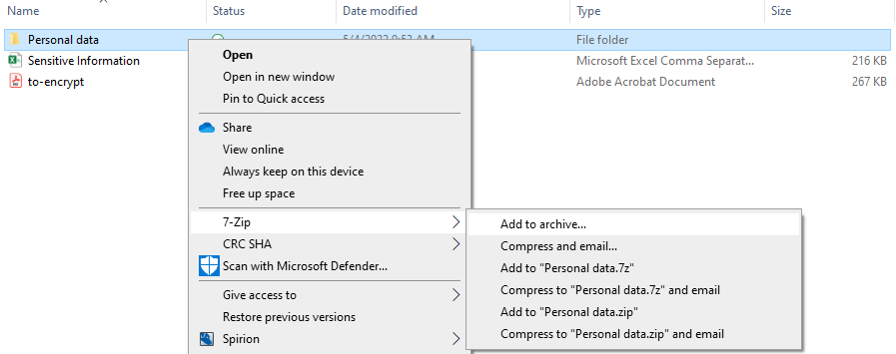
- There are 6 options 7-Zip allows.
  - Add to archive…: If this is your first time adding to a 7-Zip archive, click this option to add a new archive as a 7z file. This would be the same as the option Add to “/filename/.7z”. If you have a 7z file archive that you would like to add the file/folder to, click on this option.
  - Compress and email…: Asks you to add to a 7-Zip archive through a pop-up with different compression options (.7z, .zip, etc.), and attaches the archive to a newly drafted email.
  - Add to “/filename/.7z”: Creates a new archive under the same filename as a 7z file immediately.
  - Compress to “/filename/.7z” and email…: Creates a new archive under the same filename as a 7z file immediately and attaches the archive to a newly drafted email.
  - Add to “/filename/.zip”: Creates a compressed zip folder immediately using the same filename.
  - Compress to “/filename/.zip” and email: Creates a compressed zip folder immediately using the same filename and attaches the zipped folder to a newly drafted email.
Select the option that is most appropriate to you. We suggest clicking “Add to archive…” as it is the most customizable.
- A pop-up should show up with the following options:
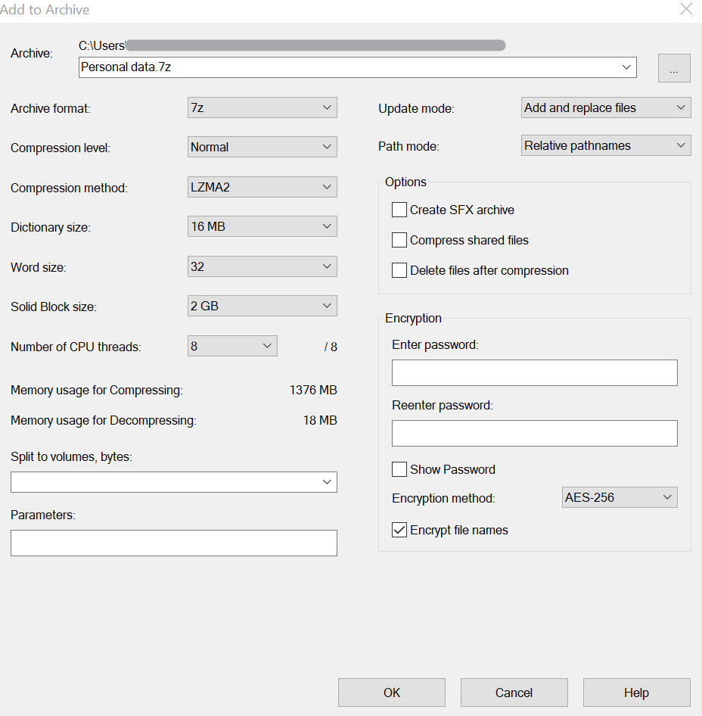
- Locate the Encryption section. There are two fields for entering a new password. Enter a strong password of at least 8 characters using capital and lowercase letters, numbers, and special characters in the first field. Reenter the same password in the second field.
**Note: Do not lose this password as it is crucial for accessing this data**
- Locate the Options section. Click on “Delete files after compression” to easily delete the non-encrypted file/folder from the PC.
  - You may skip this step, but you would need to delete the original file/folder after compression. It will still be in the same directory, with one non-encrypted and the other encrypted, such as the following:
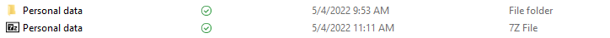
  - If the option was selected, the original file/folder will immediately be deleted, as it is already saved to the encrypted archive file. This is recommended as users may forget to delete the original unprotected file/folder after compression.
- Click OK at the bottom of the pop-up to save your selections/entries. You have now successfully created a password-protected archive to store sensitive data.

Viewing/Extracting the password-protected files/folders
- To view or extract the files, right click on the encrypted file and hover over the 7-Zip selection to expand the options:
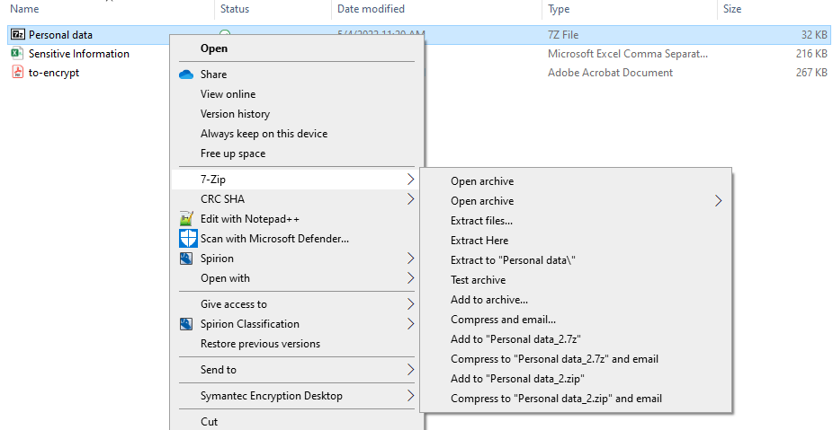
- If you were to click any of the options, you will see 7-Zip pop up a password prompt:
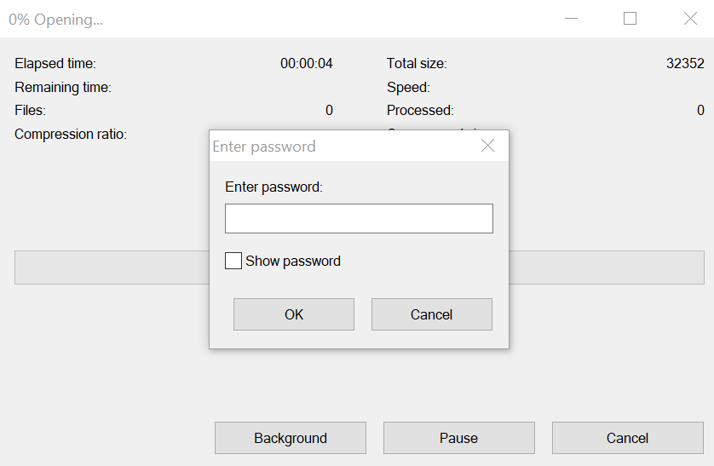
This ensures that all the data in the file is protected. Enter the strong password that was created, and the files/folders that were added should now be viewable.

Adding additional sensitive files/folders
- For additional files/folders with sensitive information, you may choose to create a new archive with a unique, strong password. Otherwise, you can add the files/folders to the archive you already created. Right-click on the file(s)/folder(s) (if there are multiples, hold Ctrl and click the additional files/folders) you would like to add to archive, and hover over the 7-Zip selection.
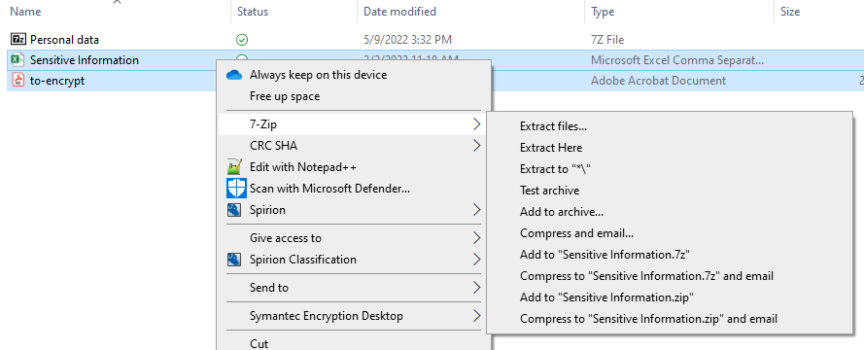
- Click on “Add to archive…”. You will see the same prompt as if you were creating a new archive, as mentioned in the previous steps.
- Change the archive using the downwards carrot sign at the right of the “Archive” field or click on the ellipses button to browse for the desired archive on your PC.
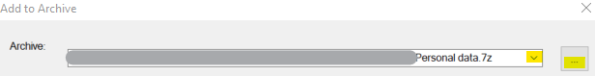
- Click on “Delete files after compression” to easily delete the non-encrypted file/folder from the PC, as mentioned in the previous section.

- Re-enter the archive’s password under the Encryption section.
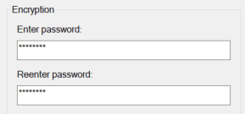
- Click “OK” at the bottom to store the files to the archive.
- You will now see the files/folders that you just added to the archive when you open it. Please see the previous section on how to view/extract the files/folders.

You have successfully password-protected sensitive information on your workstation. Thank you for your cooperation!

 | IT Security & Compliance  ITSecurity@calstatela.edu  California State University, Los Angeles  5151 State University Drive  Los Angeles, CA 90032  T 323.343.2575  calstatela.edu | Pushing Boundaries

